Chapter one

2. Suppose Alice, an ambassador of country A wants to invite Bob, an ambassador of
country B, over for dinner. Alice doesn’t simply just call Bob on the phone and say,
“come to our dinner table now”. Instead, she calls Bob and suggests a date and time.
Bob may respond by saying he’s not available that particular date, but he is available
another date. Alice and Bob continue to send “messages” back and forth until they
agree on a date and time. Bob then shows up at the embassy on the agreed date,
hopefully not more than 15 minutes before or after the agreed time. Diplomatic
protocols also allow for either Alice or Bob to politely cancel the engagement if they
have reasonable excuses.

6. The Internet’s connection-oriented service provides reliable data transfer by using
acknowledgements and retransmissions. When one side of the connection doesn’t
receive an acknowledgement (from the other side of the connection) for a packet it
transmitted, it retransmits the packet.

8. In a packet switched network, the packets from different sources flowing on a link do not follow any fixed, pre-defined pattern. In TDM circuit switching, each host gets
The same slot in a revolving TDM frame.

Problem 8:

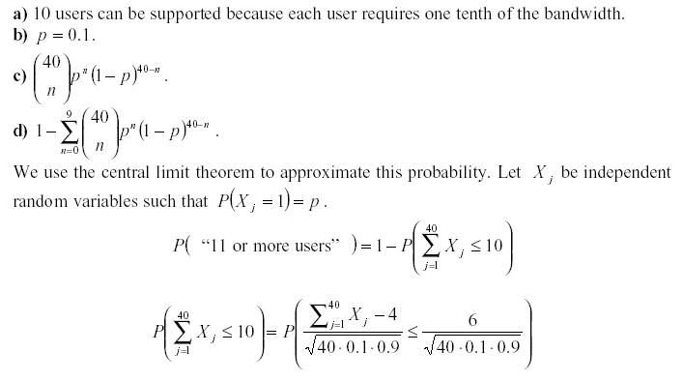

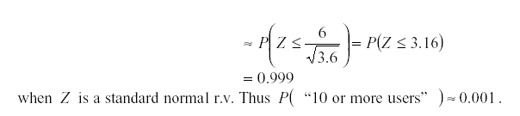

Problem 16:

a) 40,000,000 bits
b) 400,000 bits
c) .25 meters

